**Unity 3D Project**

**A**

**Project Report Submitted**

in the Partial Fulfillment of the Requirements

for the award of

**Bachelor of Technology**

in

**Computer Science and Engineering**

by

**ARCHIT SHARMA(2004480100001)**

**UDAYBHAN KUMAR(2104480109014)**

Under the Guidance of

**Mrs. Fatima Bi**

**Department of Computer Science & Engineering**



**Neelam college of enginnering and technology,**

**Agra**

**to the**



**DR. A.P.J. ABDUL KALAM TECHNICAL UNIVERSITY**

**LUCKNOW (UP), INDIA**

**MAy-2024**

**DECLARATION**

*I hereby declare that this submission is my own work and that, to the best of my knowledge and belief, it contains no material previously published or written by another person nor material which to a substantial extent has been accepted for the award of any other degree or diploma of the university or other institute of higher learning, except where due acknowledgment has been made in the text.*

*Signature:*

*Name : ARCHIT SHARMA*

*Roll No. : 2004480100001*

*Signature:*

*Name : UDAYBHAN KUMAR*

*Roll No. : 2104480109014*

**CERTIFICATE**

This is to certify that *Project Report entitled – Unity 3D Project* which is submitted by *Archit Sharma (2004480100001) Udaybhan Kumar(2104480109014)* in partial fulfilment of the requirement for the award of degree B.Tech. in Department of CSE, of Dr A.P.J. Abdul Kalam Technical University, U.P, Lucknow, is a record of the candidate own work carried out by him/her under my/our supervision. The matter embodied in this Project report is original and has not been submitted for the award of any other degree.

### Date: Project Guide

**Mrs. Fatima Bi**

**Agra**

**Acknowledgment**

*It gives us a great sense of pleasure to present the report of the B.Tech Project undertaken during B.Tech Final Year. We own special debt of gratitude to our guide Mrs. Fatima Khan Department of CSE, Neelam College of Enginnering and Technology, Agra for his constant support and guidance throughout the course of our work. His sincerity, thoroughness and perseverance have been a constant source of inspiration for us. It is only his cognizant efforts that our endeavours have seen light of the day*.

*We also take the opportunity to acknowledge the contribution of Mr. Ankit Garg, Department of CSE, , Neelam College of Enginnering and Technology, Agra, for his full support and assistance during the development of the project.*

*We also do not like to miss the opportunity to acknowledge the contribution of all faculty members of the department for their kind assistance and cooperation during the development of our project. Last but not the least, we acknowledge our friends for their contribution in the completion of the project.*

|  |  |  |
| --- | --- | --- |
| *Signature*  *Name* | *: ARCHIT SHARMA* | *Signature:*  *Name : UDAYBHAN KUMAR* |
| *Roll No.* | *: 2004480100001* | *Roll No. : 2104480109014* |
|  |  |  |

**TABLE OF CONTENT**

1. **Introduction**
2. **Project Setup**
3. **Scene Setup**
4. **Player Controller**
5. **Environment interaction**
6. **UI Development**
7. **Game Mechanics**
8. **Polishing and Optimization**
9. **Deployment**

**10. Conclusion**

1. **Introduction**

Welcome to "Gun Game: Tactical Warfare", an immersive Unity 3D project designed to provide players with an adrenaline-pumping experience of combat in a dynamic virtual environment. In this game, players are thrust into intense battles where their survival depends on quick reflexes, strategic thinking, and precise marksmanship. Unity gives users the ability to create games and experiences in both 2D and 3D, and the engine offers a primary scripting API in C# using Mono, for both the Unity editor in the form of plugins, and games themselves, as well as drag and drop functionality.

Unity is a cross-platform game engine developed by Unity Technologies, first announced and released in June 2005 at Apple Worldwide Developers Conference as a Mac OS X game engine. The engine has since been gradually extended to support a variety of desktop, mobile, console, augmented reality, and virtual reality platforms. It is particularly popular for iOS and Android mobile game development, is considered easy to use for beginner developers, and is popular for indie game development.

The engine can be used to create [three-dimensional](https://en.wikipedia.org/wiki/Three-dimensional_space) (3D) and [two-dimensional](https://en.wikipedia.org/wiki/Plane_(mathematics)) (2D) games, as well as interactive [simulations](https://en.wikipedia.org/wiki/Computer_simulation).

**History**

The Unity game engine launched in 2005, aiming to "democratize" game development by making it accessible to more developers. It was shown at Worldwide Developers Conference 2005 by Scott For stall on Mac OS X. The next year, Unity was named runner-up in the Best Use of Mac OS X Graphics category in Apple Inc.'s Apple Design Awards. Unity was initially released for Mac OS X, later adding support for Microsoft Windows and Web browsers.

**Unity 2.0 (2007)**

Unity 2.0 launched in 2007 with approximately 50 new features. The release included an optimized terrain engine for detailed 3D environments, real-time dynamic shadows, directional lights and spotlights, video playback, and other features. The release also added a version control system to allow developers to collaborate more easily. It included a Networking Layer for developers to create multiplayer games based on the User Datagram Protocol, offering Network Address Translation, State Synchronization, and Remote Procedure Calls. When Apple launched its App Store in 2008, Unity quickly added support for the iPhone. For several years, the engine was uncontested on the iPhone and it became well known with iOS game developers.

**Unity 3.0 (2010)**

Unity 3.0 launched in September 2010 with features expanding the engine's graphics features for desktop computers and video game consoles. In addition to Android support, Unity 3 featured integration of Illuminate Labs' Beast Light map tool, deferred rendering, a built-in tree editor, native font rendering, automatic UV mapping, and audio filters, among other things. In 2012 Venture Beat wrote, "Few companies have contributed as much to the flowing of independently produced games as Unity Technologies. More than 1.3 million developers are using its tools to create gee-whiz graphics in their iOS, Android, console, PC, and web-based games. Unity wants to be the engine for multi-platform games, period." A May 2012 survey by Game Developer magazine indicated Unity as its top game engine for mobile platforms.

**Unity 4.0 (2012)**

In November 2012, Unity Technologies delivered Unity 4.0. This version added DirectX 11 and Adobe Flash support, new animation tools called Mechanism, and access to the Linux preview.

Facebook integrated a software development kit for games using the Unity game engine in 2013. This featured tools that allowed tracking advertising campaigns and deep linking, where users were directly linked from social media posts to specific portions within games, and easy in-game-image sharing. In 2016, Facebook developed a new PC gaming platform with Unity. Unity provided support for Facebook's gaming platforms, and Unity developers could more quickly export and publish games to Facebook.

**Unity 5 (2015)**

The Verge said of 2015's Unity 5 release: "Unity started with the goal of making game development universally accessible. Unity 5 is a long-awaited step towards that future." With Unity 5, the engine improved its lighting and audio. Through Web GL, Unity developers could add their games to compatible Web browsers with no plug-ins required for players. Unity 5.0 offered real-time global illumination, light mapping previews, Unity Cloud, a new audio system, and the NVidia PhysX 3.3 physics engine. The fifth generation of the Unity engine also introduced Cinematic Image Effects to help make Unity games look less generic. Unity 5.6 added new lighting and particle effects, updated the engine's overall performance, and added native support for Nintendo Switch, Facebook Game room, Google Daydream, and the Vulcan graphics API. It introduced a 4K video player capable of running 360-degree videos for virtual reality.

However, some gamers criticized Unity's accessibility due to the high volume of quickly produced games published on the Steam distribution platform by inexperienced developers. Former CEO John Riccitiello said in an interview that he believes this to be a side-effect of Unity's success in democratizing game development: "If I had my way, I'd like to see 50 million people using Unity – although I don't think we're going to get there any time soon. I'd like to see high school and college kids using it, people outside the core industry. I think it's sad that most people are consumers of technology and not creators. The world's a better place when people know how to create, not just consume, and that's what we're trying to promote."

**Annual releases (2017–2023)**

In December 2016, Unity Technologies announced that they would change the version numbering system for Unity from sequence-based identifiers to year of release to align the versioning with their more frequent release cadence; Unity 5.6 was therefore followed by Unity 2017. Unity 2017 tools featured a real-time graphics rendering engine, color grading and world building, live operations analytics and performance reporting. Unity 2017.2 underscored Unity Technologies' plans beyond video games. This included new tools such as Timeline, which allowed developers to drag-and-drop animations into games, and Cine machine, a smart camera system within games. Unity 2017.2 also integrated Autodesk's 3DS Max and Maya tools into the Unity engine for a streamlined asset sharing in-game iteration process.

**Unity 6 (2024)**

On November 16, 2023, Unity announced that the next version of the engine would be called Unity 6, reverting to the previous version numbering convention. Unity 6 is planned for release in 2024, with planned features including new generative AI tools called Unity Muse and Unity Sentries. Unity 6 also makes use of the revised licensing agreement, including the "runtime fee".

**Objective:**

Your mission is clear: eliminate all enemy forces that stand in your way. Whether it's battling through waves of AI-controlled adversaries or competing against other players in multiplayer mode, your primary goal is to emerge victorious by mastering the art of combat.

**Gameplay Features:**

**1.** **Diverse Arsenal**: Explore a wide range of firearms, from pistols and shotguns to assault rifles and sniper rifles. Each weapon offers unique attributes and handling characteristics, allowing players to customize their loadout according to their preferred playstyle.

1. **Dynamic Environments**: Engage in fast-paced firefights across a variety of meticulously crafted environments, including urban cityscapes, dense forests, and desolate wastelands. Adapt to the ever-changing terrain as you seek cover, flank enemies, and seize tactical advantages.
2. **Enemy AI**: Encounter intelligent enemy AI that reacts dynamically to your actions. Prepare for challenging encounters as foes employ advanced tactics, coordinate attacks, and exploit weaknesses in your defenses. Every battle presents a new test of your combat skills.
3. **Progression System**: Earn experience points and unlock new weapons, equipment, and abilities as you progress through the game. Customize your character to suit your preferred playstyle, whether it's specializing in long-range sniping, close-quarters combat, or stealthy infiltration.
4. **Multiplayer Mode**: Challenge friends and players from around the world in exhilarating multiplayer battles. Test your skills in team-based skirmishes, free-for-all deathmatches, and objective-based missions. Form alliances, coordinate strategies, and prove your dominance on the battlefield.

**Conclusion:**

"Gun Game: Tactical Warfare" offers an immersive and action-packed gaming experience that will keep players on the edge of their seats. With its stunning visuals, realistic gun mechanics, and intense multiplayer battles, this Unity 3D project promises to deliver hours of adrenaline-fueled excitement for both casual gamers and hardcore enthusiasts alike.

**2.** **Project Setup : Gun Game Development**

Ensure you have Unity 3D installed on your system. The recommended version is Unity 2020.3 LTS (Long Term Support) or newer for stability and compatibility with the latest features and packages.

**Starting Unity for the first time**

When you launch the Unity Editor, the Home Screen appears. If you have no existing Unity Projects on your computer, or if this is your first time opening the Unity Editor, the Home Screen displays the Learn tab.

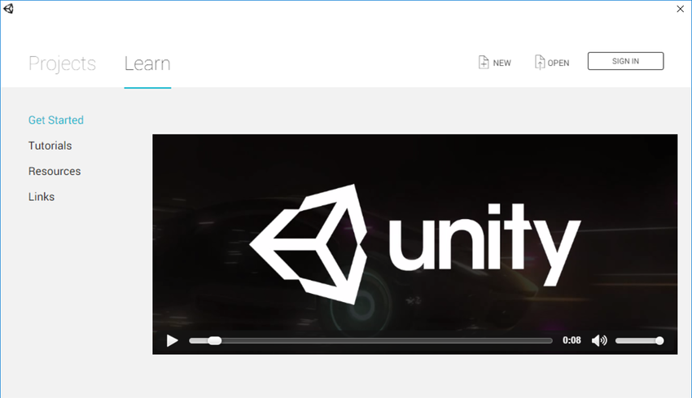

The Learn tab in the Home Screen.

From the Learn tab, you can access tutorials and learning resources to help you get started with Unity. If you are new to using Unity, you should work through the Unity Learn tutorials before starting a new project.

**The Projects tab**

From the Home Screen, click Projects to view the Projects tab.

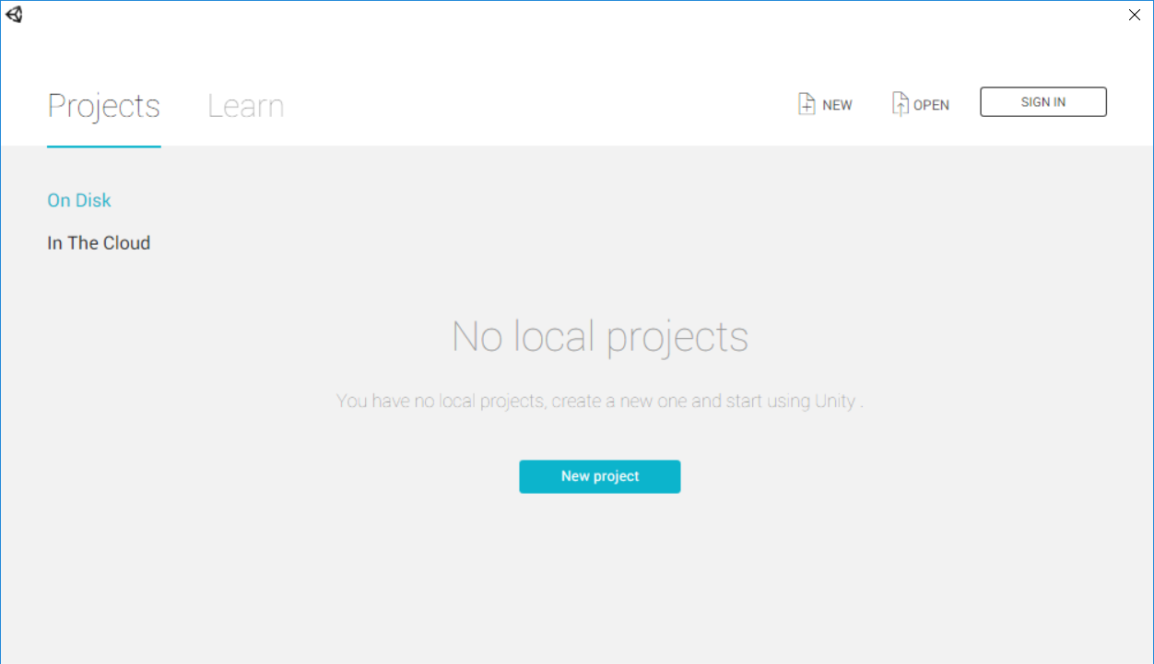

The Project tab in the Home Screen

To open a new Project, click New. This opens the Create Project view.

To open an existing Unity Project stored on your computer, click the Project name in the Projects tab, or click Open to browse your computer for the Project folder.

To access Unity Collaborate Projects, click In The Cloud, then select the Project that you want to load. You will then be prompted to chose a storage location for this project on your computer.

**Creating a Project**



In the top right corner of the Home Screen, click ‘New’ to see the Create Project window.

To access the Home Screen when you are already in the Unity Editor, go to File > New Project ….

From the Create Project window, there are various starter settings for you to apply before Unity creates your project. These are described in detail below

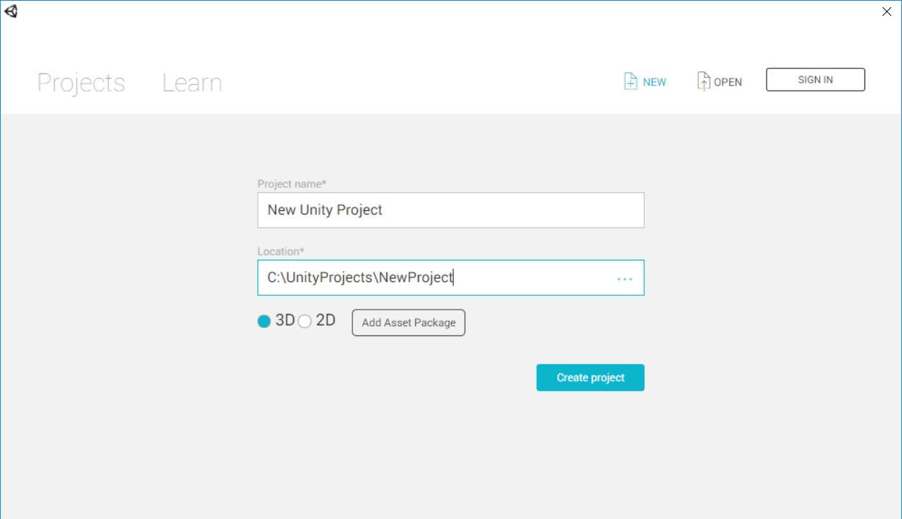

The Home Screen’s Create Project window.

Select Create Project when you’re done. Unity automatically generates the required files and creates your Project.

**Opening a Project**

The Home Screen’s Project tab lists any Project you have previously opened on this computer. Click on a Project in the list to open it.

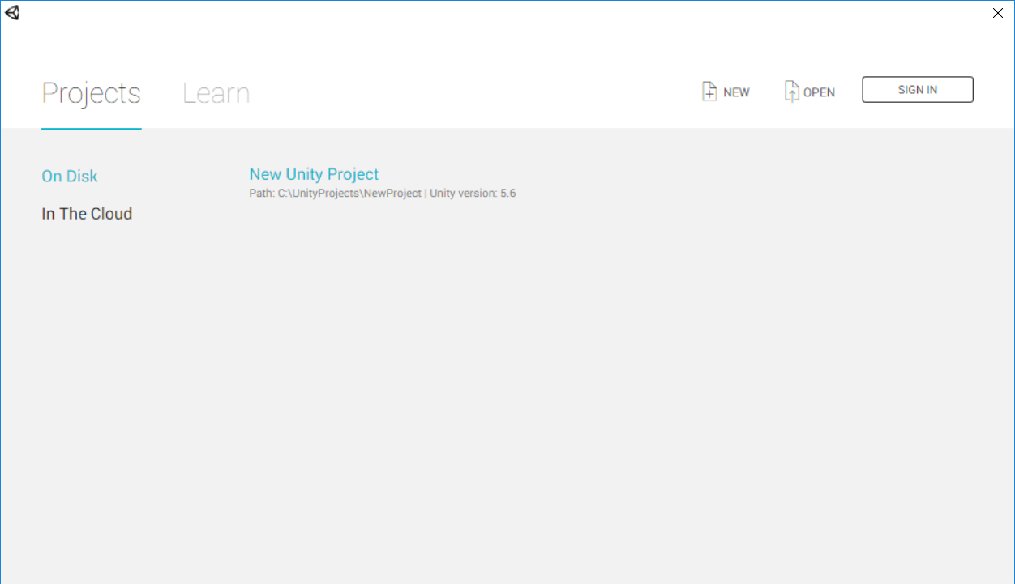

A Project listed in the Projects tab.

If the Editor is newly installed, or you haven’t yet opened the Project you need in this installation of Unity, click Open to open your file browser and locate the Project folder. Note that a Unity Project is a collection of files and directories, rather than just one specific Unity Project file. To open a Project, you must select the main Project folder, rather than a specific file).

To bring up the Home Screen’s Projects tab from inside the Unity Editor, go to File > Open Project.

**IDE (Integrated Development Environment):**

You can use any code editor or IDE of your choice, such as Visual Studio or JetBrains Rider, for scripting in C# within Unity.

An integrated development environment (IDE) is a piece of computer software that provides tools and facilities to make it easier to develop other pieces of software. Unity supports the following IDEs:

* Visual Studio
* Visual Studio Code
* Jet Brains Rider

1. **Visual Studio (default IDE on Windows and mac OS)**

When you install Unity on Windows and mac OS, by default Unity also installs Visual Studio or Visual Studio for Mac, respectively. You can choose to exclude it when you select which components to download and install. By default, the External Script Editor (menu: Unity > Preferences > External Tools > External Script Editor) is set to Visual Studio. When you enable this option, Unity launches Visual Studio and uses it as the default editor for all script files. For more information, see Visual Studio C# Integration.

On mac OS, Unity installs Visual Studio for Mac as the C# IDE. Visual Studio Tools for Unity (VSTU) provides Unity integration for Visual Studio for Mac (VS4M). For information on setting up and using Visual Studio for Mac, see the following Microsoft documentation pages:

* Visual Studio Tools for Unity
* Setup Visual Studio for Mac Tools for Unity
* Using Visual Studio for Mac Tools for Unity

Note: On Windows, Unity also includes Visual Studio 2019 Community by default in the installation package.

1. **Visual Studio Code (Windows, mac OS, Linux)**

Unity supports opening scripts in Visual Studio Code (VS Code). To open scripts in VS Code, go to Unity > Preferences > External Tools > External Script Editor and select Visual Studio Code. For information on using VS Code with Unity, see Visual Studio’s documentation on Unity Development with VS Code.

**Prerequisites**

To use Visual Studio Code for C# code editing and Unity C# debugging support, you need to install:

* Mono (only required on mac OS and Linux)
* Visual Studio Code C# Extension
* Visual Studio Code Debugger for Unity Extension (Not officially supported by Unity)
* Jet Brains Rider (Windows, mac OS, Linux)

Unity supports opening scripts in Jet Brains Rider. To open scripts in Rider, go to Unity > Preferences > External Tools > External Script Editor and select Rider.

Rider is based on Re Sharper and includes most of its features. It supports all of C# 7.2’s features as well as C# debugging on the .NET 4.6 scripting runtime in Unity. For more information, see Jet Brains’ documentation on Rider for Unity.

**Setting Up Your Scripting Environment**

* This section provides information on a few common tasks associated with setting up your environment for scripting.

**These include:**

* Integrated development environment (IDE) support Use your choice of code editor when working in Unity.
* Debugging C# code in Unity Connect external debuggers to Unity to set breakpoints, and pause to inspect your project’s state.
* Unit testing Run automated tests on your code to ensure it continues to work correctly.
* Roslyn analyzers and source generators Use analyzers to inspect your code for style, quality, and other issues.

**Necessary Plugins/Packages:**

1. **Unity Hub**: Use Unity Hub to manage multiple Unity versions and projects efficiently. Download and install it from the official Unity website.
2. **Standard Assets**: Unity's Standard Assets package provides essential resources such as character controllers, vehicles, and environment assets. Import this package into your project to access pre-made assets that can accelerate development.
3. **Cine machine**: Cine machine is a powerful camera system for Unity that enables dynamic camera movements, transitions, and composition. Install it via the Unity Package Manager to enhance your game's visuals and cinematic quality.
4. **Pro Builder:** Pro Builder is a versatile 3D modeling tool integrated into Unity for creating and editing 3D geometry directly within the editor. It's useful for prototyping levels, props, and environmental elements. Install it through the Unity Package Manager to streamline level design workflows.

**Setting up the Environment:**

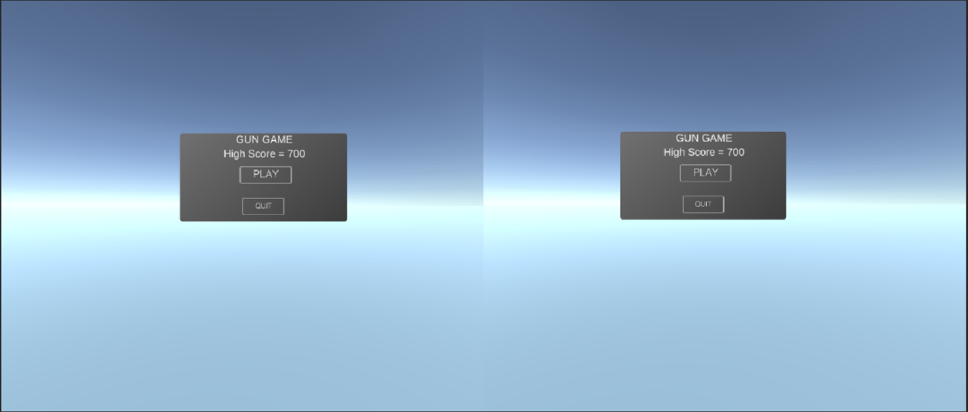

1. **Create a New Unity Project**: Open Unity Hub, create a new project, and select the 3D template. Choose a project name and location on your system.
2. **Import Necessary Packages**: Once inside the Unity editor, navigate to the Package Manager window. Install the Standard Assets, Cine machine, and Pro Builder packages if they're not already included in your project.
3. **Set Up Scene and Assets**: Design your game scene by importing assets such as terrain, props, and character models. Utilize Pro Builder to create custom level geometry or modify existing meshes.
4. **Scripting**: Begin scripting enemy behaviors, player controls, weapon mechanics, and game logic using C# scripts. Attach scripts to appropriate Game Objects to define their functionality within the game.
5. **Testing and Iteration**: Test your game frequently to identify bugs, refine gameplay mechanics, and optimize performance. Use Unity's built-in debugging tools to diagnose issues and make necessary adjustments.

**Conclusion:**

With Unity 3D, an appropriate IDE, and essential Plugins/packages installed, you're ready to embark on the exciting journey of Gun Game development. Follow these setup instructions to create a captivating gaming experience where players must eliminate enemies to emerge victorious.

**3.Scene Setup for Gun Game Development**

* **Debug C# code in Unity**

You can use a debugger to inspect your source code while your application is running. Unity supports the following code editors to debug C# code:

* Visual Studio (with the Visual Studio Tools for Unity plug-in)
* Visual Studio for Mac
* Jet brains Rider

Note that while the Visual Studio IDE supports Unity debugging, the Visual Studio Code text editor does not.

Although these code editors vary slightly in the debugging features they support, they all provide basic functionality such as break points, single stepping, and variable inspection. You can attach these code editors to the Unity Editor or Unity Player to debug your code.

Managed code debugging in Unity works on all platforms except Web GL. It works with both the Mono and IL2CPP scripting backend.

* **Configure the code editor**

**Visual Studio (Windows)**

The Unity Editor installer includes an option to install Visual Studio with the Visual Studio Tools for Unity plug-in. This is the recommended way to set up Visual Studio for debugging with Unity.

If Visual Studio is already installed on your computer, open it and go to Tools > Get Tools and Features… to locate and install the Visual Studio Tools for Unity plug-in.

**Visual Studio for Mac**

The Unity Editor installer includes an option to install Visual Studio for Mac. This is the recommended way to set up Visual Studio for Mac for debugging with Unity.

If Visual Studio for Mac is already installed on your computer, open it and go to Visual Studio > Extensions > Install from file… to locate and install the Visual Studio Tools for Unity plug-in.

**Jet Brains Rider**

You can use the default installation of Jet Brains Rider to debug code in Unity on Windows or Mac. Visit the Jet Brains website to install it.

**Specify the External Script Editor in Unity**

Once you’ve installed a code editor, open Unity, go to Preferences > External Tools and set the External Script Editor to your code editor.

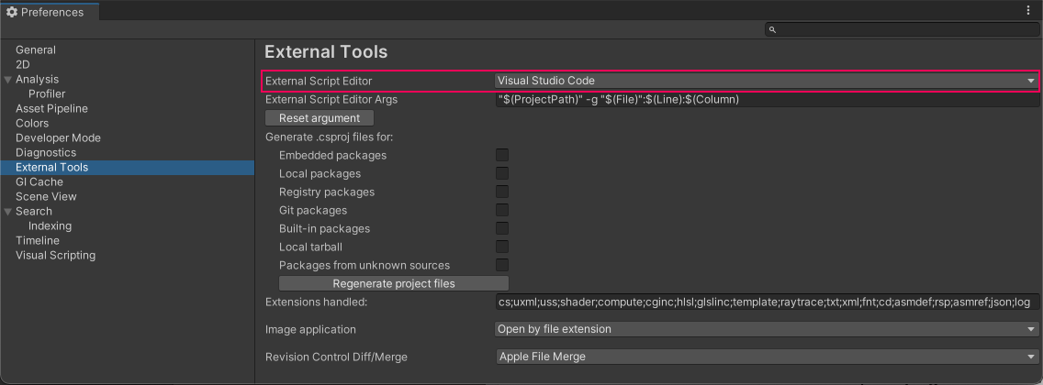

The External Tools settings

**Breakpoints**

Breakpoints allow you to specify points in your code where you want to pause its execution. In your external code editor, you can set a breakpoint on a line of code where you want the debugger to stop. While the code editor is at a breakpoint, you can view the contents of variables step by step.

If you have attached your code editor to the Unity Editor (see Attach your code editor to the Unity Editor), the Unity Editor becomes unresponsive until you choose the continue option in your code editor, or stop debugging mode.

To see how you can set breakpoints in Visual Studio see Set breakpoints in Visual Studio.

**Debug in the Unity Editor**

You can debug C# code as it runs in the Unity Editor while the Unity Editor is in Play Mode.

To debug in the Editor, you need to set the Editor’s Code Optimization mode to Debug Mode, then you can attach a code editor with a debugging feature.

To change the Code Optimization mode, select the Debug Button in the bottom right of the Unity Editor Status Bar.

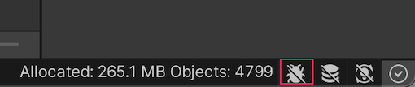

The Debug Button in the bottom right of the Unity Editor Status Bar.

Unity’s Code Optimization setting has two modes:

* Debug Mode, which you can use to attach external debugger software, but gives slower C# performance when you run your Project in Play Mode in the Editor.
* Release Mode, which gives faster C# performance when you run your Project in Play Mode in the Editor, but you cannot attach any external debuggers.

When you click the Debug button in the status bar, a small pop-up window opens which contains a button you can use to switch modes. The window also displays information about the current mode, and describes what happens if you switch modes.

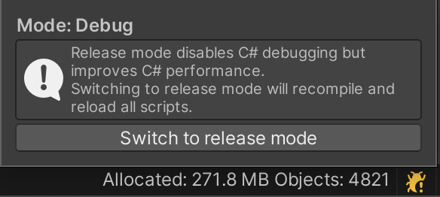

The Debug Mode popup, which shows the current mode, allows you to switch modes, and describes what happens if you switch mode.

To change which mode the Unity Editor starts up in, go to Edit (mac OS: Unity) > Preferences > General > Code Optimization On Startup.

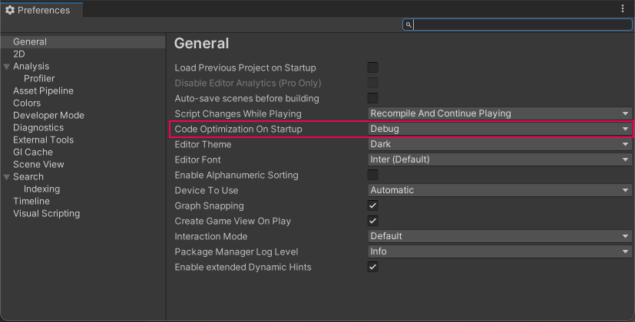

In Preferences, you can change the Code Optimization mode that Unity starts in.

To control these settings using a script, use the following API:

* Managed Debugger
* Compilation Compilation Pipeline-code Optimization
* Compilation Code Optimization.

You can also override the mode that the Editor starts up in, or turn off the debugger listen socket. To do this, use the following command line arguments when you launch the Editor:

* -release Code Optimization. Starts the Editor in Release code optimization mode.
* -debug Code Optimization. Starts the Editor in Debug code optimization mode.
* -disable Managed Debugger. Starts the Editor with the debugger listen socket disabled.

**Attach your code editor to the Unity Editor**

The way to attach your code editor to the Unity Editor depends on what code editor you use, and is often a different option from your code editor’s normal debugging process. Some code editors allow you to select an instance of Unity to debug. For instructions specific to your code editor, see Code editor external documentation. To see how you can do this in Visual Studio, see Attach Visual Studio to the Unity Editor.

When you have attached the code editor to the Unity Editor and you are ready to begin debugging, return to the Unity Editor and enter Play Mode.

**Debug in the Unity Player**

To compile a Unity Player for you to debug:

1. Go to File > Build Settings.
2. Enable the Development Build and Script Debugging options before you build the Player. You could also enable the Wait For Managed Debugger option to make the Player wait for a debugger to be attached before the Player executes any script code.
3. Select Build And Run.

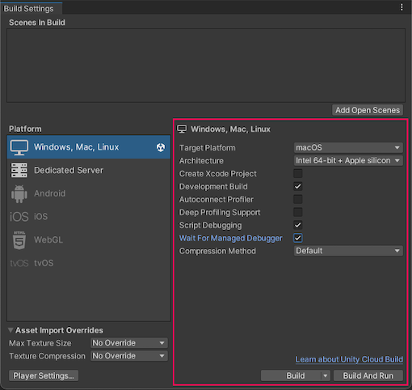

**1. Terrain Creation:**

* Create a new terrain by selecting Game Object -> 3D Object -> Terrain.
* Use the Terrain Tools to sculpt the terrain to fit your level design, including hills, valleys, and obstacles.
* Apply textures and foliage to the terrain to enhance visual appeal and provide cover for players and enemies.

**2. Lighting Setup:**

* Add directional light to simulate sunlight and create shadows in the scene.
* Adjust light settings such as intensity, color, and shadows to achieve the desired ambiance.
* Utilize additional light sources (point lights, spotlights) to illuminate specific areas or enhance visual effects.

**3. Camera Setup:**

* Create a new camera Game Object to serve as the player's perspective.
* Adjust the camera's position, rotation, and field of view to provide optimal visibility and gameplay experience.
* Implement camera controls (e.g., mouse or joystick input) to enable players to move the camera view freely or focus on specific targets.

**4. Environment Assets:**

* Populate the scene with environmental assets such as buildings, foliage, rocks, and other props to create a realistic and immersive setting.
* Place interactive objects like doors, switches, or destructible elements to add depth to the gameplay and encourage exploration.

**5. Player and Enemy Spawning:**

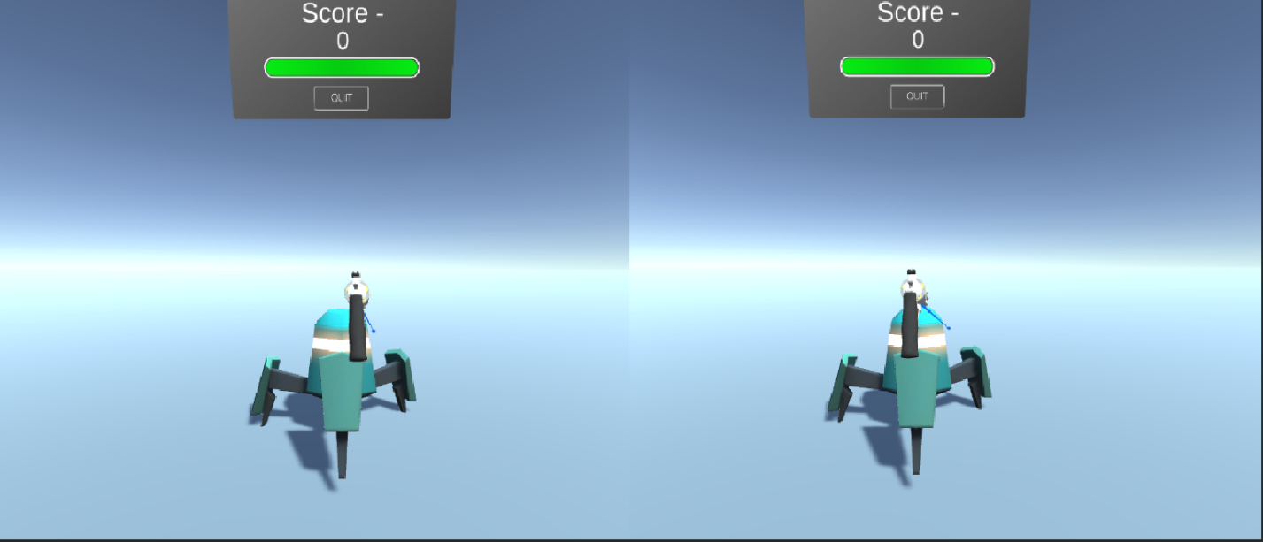

* Position spawn points for players and enemies strategically throughout the level.
* Ensure spawn points are placed in safe locations for players and provide sufficient cover to avoid spawn camping.
* Implement spawning logic to dynamically generate enemies based on player proximity or predefined triggers.

**6. Weapon and Ammo Placement:**

* Scatter weapon pickups and ammo crates across the level to supply players with firepower and ammunition.
* Distribute weapons strategically to encourage exploration and risk-reward decisions.
* Use scripting to respawn weapons and ammo over time or upon player interaction.

**7. Navigation and Pathfinding:**

* Set up navigation meshes or waypoints to enable AI-controlled enemies to navigate the environment intelligently.
* Implement pathfinding algorithms (e.g., A* algorithm) to calculate optimal routes for enemies to pursue players or patrol designated areas.

**8. Audio Integration:**

* Add background music, ambient sounds, and sound effects to enhance immersion and atmosphere.
* Trigger audio cues based on gameplay events such as gunfire, explosions, and enemy encounters to provide feedback to players.

**Conclusion:**

By following these steps, you can create captivating game scenes for your Gun Game project in Unity. Remember to playtest the scenes regularly to ensure balanced gameplay, smooth performance, and an enjoyable player experience.

1. **Player Controller Setup:**

**Character Controller component reference**

**SWITCH TO SCRIPTING**

The Character Controller is mainly used for third-person or first-person player control that does not make use of Rigid body physics.

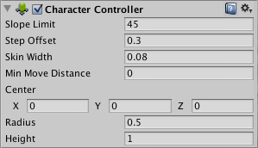

**1. Creating the Player Controller Script:**

* Open your preferred code editor (e.g., Visual Studio or JetBrains Rider).
* Create a new C# script named "Player Controller" or a similar descriptive name.

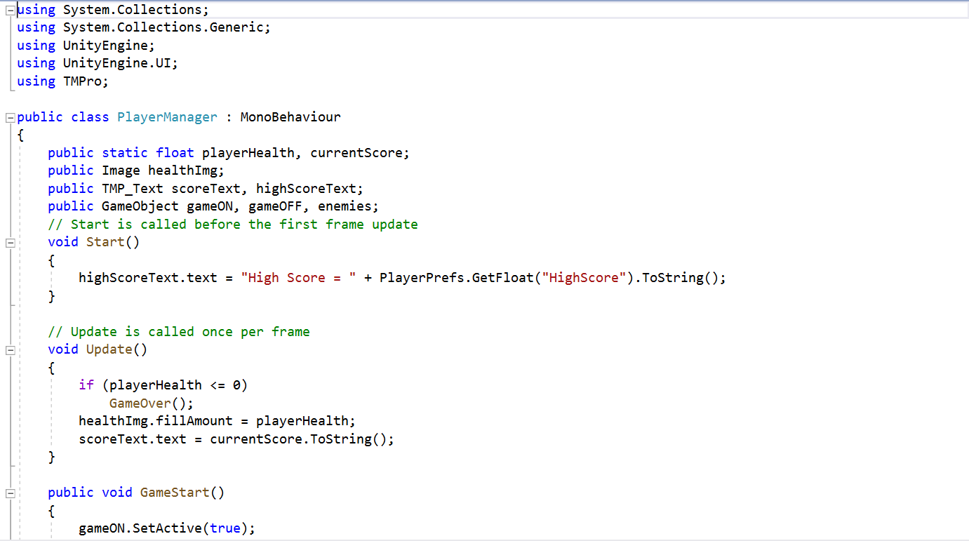

**2. Implementing Player Movement and Shooting:**

* Within the Player Controller script, define variables for player movement speed, jump force, and shooting mechanics.
* Use Unity's Input system to capture player input for movement (e.g., WASD keys or joystick) and shooting (e.g., left mouse button or gamepad trigger).
* Implement functions to handle player movement, including character rotation, forward/backward movement, strafing, and jumping.
* Implement a shooting function to instantiate bullets or projectiles from the player's weapon, applying force or damage to enemies upon collision.

**3. Attaching the Script to the Player Game Object:**

* Save the Player Controller script and return to the Unity editor.
* Select the player Game Object in the scene hierarchy.
* Drag and drop the Player Controller script from the project folder onto the player Game Object in the Inspector window.

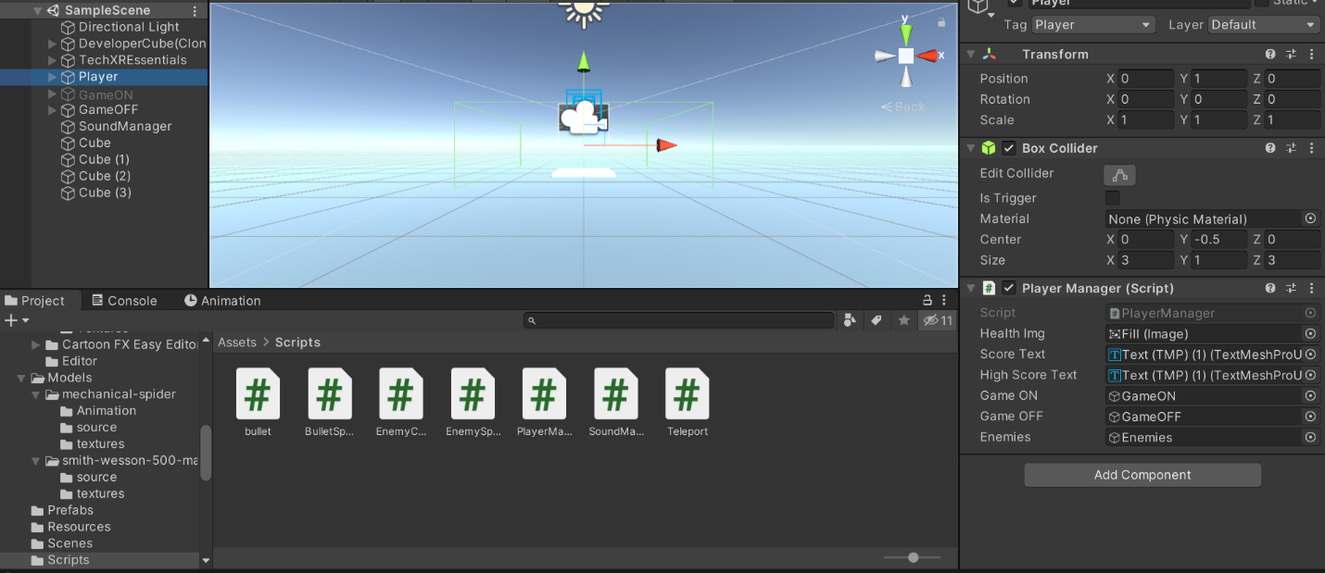

**4. Testing and Iteration:**

* Playtest the game to ensure that the player character responds correctly to input and interacts with the environment as intended.
* Fine-tune movement parameters, such as speed and jump force, to achieve smooth and responsive controls.
* Debug any issues with player movement or shooting functionality by using Unity's debugging tools and console logs.
* This script provides basic functionality for player movement, rotation, jumping, and shooting. Adjust and expand upon it according to your specific game design requirements.

1. **Environment Interaction Setup:**

**1. Implementing Pickup Items:**

* Create a script to handle the behavior of pickup items (e.g., weapons, ammo crates).
* Use collision detection to detect when the player interacts with a pickup item.
* Upon interaction, modify player inventory or attributes accordingly (e.g., add ammo to the current weapon).
* Destroy or deactivate the pickup item to prevent further interaction.

**2. Opening Doors:**

* Create a script to manage the opening and closing of doors in the game world.
* Use triggers or ray casting to detect when the player approaches a door.
* Upon interaction (e.g., pressing a designated key), trigger animations or physics-based movement to open or close the door.
* Implement optional locking mechanisms or key requirements for specific doors to add depth to gameplay progression.

**3. Code Snippets:**

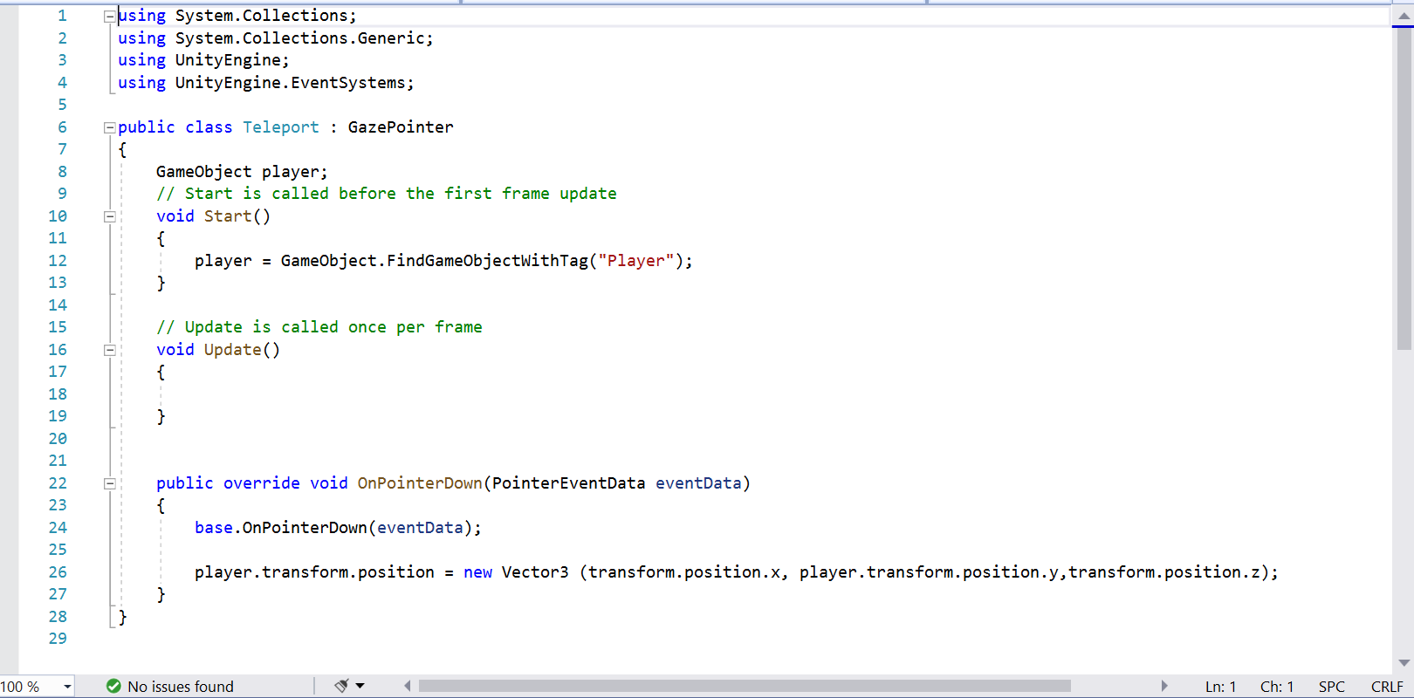

**Conclusion:**

By following these instructions and utilizing the provided code snippets, you can add engaging environment interactions to your Gun Game project in Unity. Experiment with different interaction mechanics and refine them based on your game's design and player feedback.

1. **UI Development for Gun Game:**

**1. Creating UI Elements:**

* **HUD (Heads-Up Display):** Design elements like health bars, ammo counters, and mini-maps to provide essential information to players during gameplay.
* **Menus:** Create menus such as the main menu, pause menu, settings menu, and game over menu. Include options to start or resume the game, adjust settings, and quit the game.
* **Dialogs**: Implement dialogs for in-game messages, notifications, and prompts. These can include alerts for low health, ammo pickups, or mission objectives.

**2. UI Scripting:**

* **HUD Manager Script**: This script manages updating the HUD elements based on the player's status (health, ammo, etc.).
* **Menu Manager Script**: Handles menu navigation, button clicks, and overall menu functionality.
* **Dialog Manager Script**: Controls the display and behavior of in-game dialogs, including showing and hiding them based on game events.

**3. Attaching UI Scripts to Game Objects:**

* Create empty Game Objects in your scene to act as managers for each type of UI element (HUD Manager, Menu Manager, Dialog Manager).
* Attach the corresponding script to each manager Game Object to handle UI functionality.
* Link UI elements (such as Text or Button components) to the appropriate variables in the UI scripts via the Unity Editor.

1. **Code Examples:**

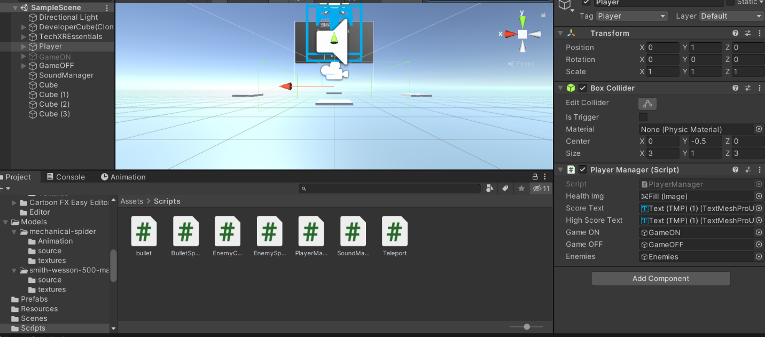

**Conclusion:**

With these UI development guidelines and code examples, you can create intuitive and immersive user interfaces for your Gun Game in Unity. Tailor the UI elements and functionality to match the theme and gameplay mechanics of your game, providing players with an engaging and enjoyable experience.

1. **Game Mechanics for Gun Game Development:**

**1. Scoring System:**

* Objective: Keep track of the player's performance and provide feedback on their progress.
* Implementation Steps:
* Create a Score Manager script to manage scoring logic.
* Award points for actions such as defeating enemies, completing objectives, or collecting items.
* Update the UI to display the player's current score.

**2. Enemy AI:**

* Objective: Create dynamic and challenging opponents for the player to engage with.
* Implementation Steps:

1. Design enemy behaviors such as patrolling, chasing, and attacking using finite state machines or behavior trees.
2. Implement line-of-sight detection to enable enemies to detect and track the player.
3. Include decision-making algorithms for enemies to determine their actions based on factors like proximity, health, and available cover,

**3. Weapon Mechanics:**

* Objective: Provide satisfying and realistic gunplay mechanics for the player.
* Implementation Steps:

1. Create a Weapon script to manage weapon properties such as damage, fire rate, and ammo capacity.
2. Implement shooting mechanics including aiming, firing projectiles, and applying damage to targets.
3. Include reloading functionality with appropriate animations and cool down times.

**4. Puzzle Mechanics:**

* Objective: Introduce puzzles or challenges to add variety and depth to gameplay.
* Implementation Steps:

1. Design puzzles that require problem-solving skills or interaction with the environment (e.g., finding keys to unlock doors, activating switches to progress).
2. Create puzzle elements such as movable objects, pressure plates, and logic gates.
3. Implement feedback mechanisms to provide hints or feedback to the player during puzzle solving.

**Code Snippets:**

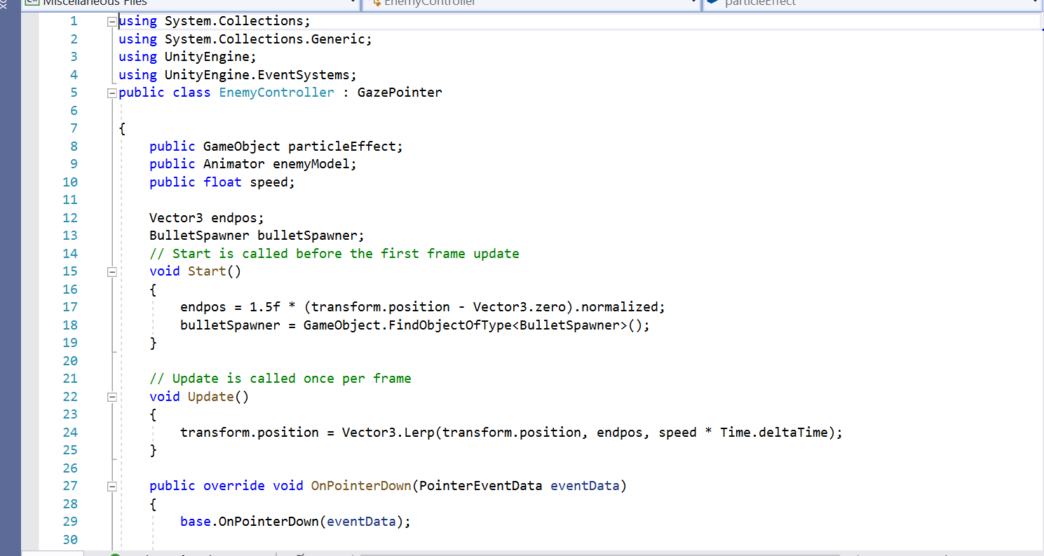

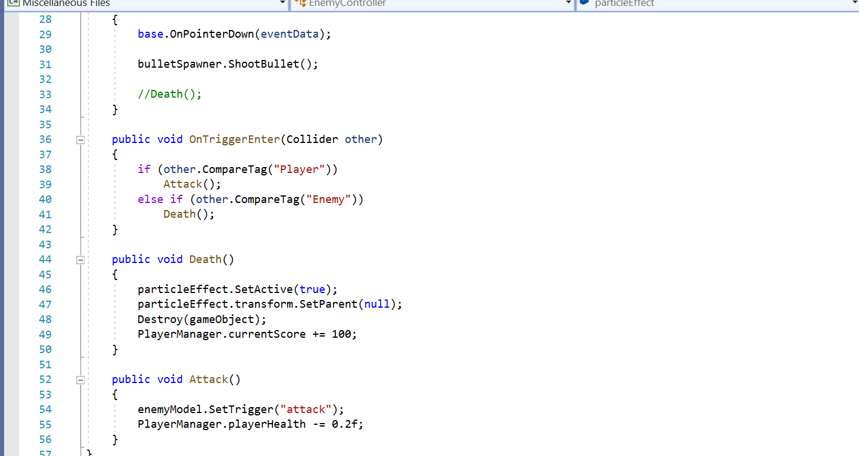

**Conclusion:**

By implementing these game mechanics, you can create a dynamic and engaging Gun Game experience for players. Experiment with different variations and combinations of mechanics to tailor the gameplay to your vision and provide an enjoyable challenge for players.

1. **Optimizing Performance:**
2. **Level of Detail (LOD):** Implement LOD groups for complex models to reduce the number of polygons rendered at a distance, improving performance.
3. **Batching**: Combine static Game Objects into fewer draw calls by utilizing batching techniques like Static Batching and Dynamic Batching.
4. **Texture Compression**: Use texture compression formats (e.g., DXT, ETC) to reduce texture memory usage without sacrificing visual quality.
5. **Culling**: Implement occlusion culling and frustum culling to avoid rendering objects that are not visible to the camera, reducing GPU workload.
6. **Shader Optimization:** Simplify shaders and use shader variants sparingly to minimize GPU overhead. Utilize GPU Profiler to identify performance bottlenecks in shaders.
7. **Lighting Optimization:** Opt for baked lighting whenever possible to reduce runtime calculations. Use light probes and occlusion culling to enhance lighting quality while maintaining performance.
8. **Asset Optimization:** Optimize 3D models and textures by reducing polygon counts and using texture atlases to minimize memory usage.

**Improving Visual Quality:**

1. **High-Quality Textures**: Use high-resolution textures for important assets to enhance visual fidelity. Utilize normal maps, specular maps, and ambient occlusion maps to add depth and realism.
2. **Post-Processing Effects:** Apply post-processing effects like bloom, ambient occlusion, and color grading to enhance the overall visual aesthetic of the game.
3. **Dynamic Lighting**: Utilize dynamic lighting effects such as real-time shadows, reflections, and particle effects to create immersive environments and engaging gunplay visuals.
4. **Particle Systems**: Implement particle systems for muzzle flashes, bullet impacts, and explosions to add visual feedback and excitement during combat encounters.
5. **Environmental Details**: Add environmental details such as foliage, debris, and interactive elements to enrich the game world and make it feel more immersive and alive.
6. **UI/UX Design**: Design intuitive and visually appealing user interfaces with clear navigation and feedback elements to enhance the overall player experience.

**Polishing Gameplay:**

1. **Balanced Difficulty:** Fine-tune enemy AI behaviors and weapon mechanics to provide a challenging but fair gameplay experience. Adjust difficulty levels based on player feedback.
2. **Feedback Systems**: Implement audiovisual feedback for player actions, such as hit indicators, sound effects, and screen shakes, to provide immediate feedback and reinforce player actions.
3. **Smooth Controls**: Ensure responsive and intuitive player controls by refining movement mechanics, aiming sensitivity, and input responsiveness.
4. **Bug Fixing:** Conduct thorough playtesting and debugging to identify and fix any gameplay bugs, glitches, or inconsistencies that may detract from the overall experience.
5. **Player Progression**: Introduce progression systems such as unlocking new weapons, abilities, or levels as players advance through the game to maintain engagement and motivation.
6. **Deployment for Gun Game:**

**1. Building for Different Platforms:**

* PC (Windows, mac OS, Linux):
* Go to File -> Build Settings in Unity.
* Select the target platform (e.g., PC, Mac, Linux) and click "Switch Platform."
* Configure build settings (e.g., resolution, graphics quality) and click "Build" to generate the executable file.
* Mobile (iOS, Android):
* Install the necessary platform-specific SDKs and tools (X code for iOS, Android Studio for Android).
* Connect your device to the computer and enable USB debugging.
* In Unity's Build Settings, select the target platform (iOS or Android) and click "Switch Platform."
* Configure player settings (e.g., bundle identifier, minimum API level) and click "Build and Run" to deploy the game directly to the device for testing.

**2. Testing and Debugging:**

* **Testing:**
* Conduct thorough testing on each platform to ensure compatibility and functionality.
* Test gameplay mechanics, UI elements, performance, and stability across different devices and screen resolutions.
* Gather feedback from play testers and iterate on any issues or suggestions.
* **Debugging:**
* Use Unity's built-in debugging tools, such as the Console window and Profiler, to identify and fix bugs.
* Utilize platform-specific debugging tools (e.g., X code Debugger for iOS, Android Debug Bridge for Android) to diagnose and troubleshoot platform-specific issues.

**3. Publishing to Distribution Platforms:**

* **Steam (PC):**
* Prepare promotional materials (e.g., screenshots, trailers, store description) and create a store page on Steam works.
* Build your game for PC and upload the executable file, along with any additional files (e.g., assets, dependencies), to Steam works.
* Set pricing, release date, and other store settings on Steam works before submitting the game for review.
* Once approved, your game will be available for purchase/download on the Steam store.
* **App Store (iOS):**
* Create an Apple Developer account and set up your app in App Store Connect.
* Generate an iOS build from Unity and submit it to App Store Connect for review.
* Provide required metadata (e.g., app name, description, screenshots) and set pricing and availability options.
* Once approved, your game will be available for download on the App Store.
* **Google Play Store (Android):**
* Create a Google Play Developer account and set up your app in the Google Play Console.
* Generate an Android build from Unity and upload the APK file to the Google Play Console.
* Fill out store listing details (e.g., app title, description, screenshots) and configure pricing and distribution settings.
* After review and approval, your game will be published on the Google Play Store.

**4. Post-launch Support:**

* **Updates and Patches**:
* Monitor player feedback and address any reported issues promptly through updates and patches.
* Release new content, features, or improvements based on player feedback and market trends to keep the game fresh and engaging.
* **Community Engagement**:
* Engage with the player community through forums, social media, and in-game communication channels to foster a supportive and active player base.
* Respond to player inquiries, feedback, and suggestions to demonstrate commitment to the game's ongoing development and improvement.

**10. Conclusion: Gun Game Development**

In conclusion, our Gun Game project is a thrilling and immersive gaming experience that puts players in the heart of intense combat scenarios. Let's summarize its key features and reflect on the development process:

* **Key Features**:
* Engaging Gunplay: Enjoy dynamic gunplay mechanics with a diverse arsenal of weapons, realistic shooting mechanics, and challenging enemies.
* Immersive Environments: Explore meticulously crafted environments ranging from urban landscapes to desolate wastelands, each offering strategic advantages and obstacles.
* Intelligent Enemy AI: Encounter intelligent enemy AI that adapts to your tactics, providing challenging and rewarding combat encounters.
* Customizable Gameplay: Customize your playstyle with a progression system that unlocks new weapons, equipment, and abilities as you advance through the game.
* Multiplayer Mode: Challenge friends and players worldwide in exhilarating multiplayer battles, showcasing your skills and strategic prowess.
* **Development Reflection:**

The development process of our Gun Game has been both challenging and rewarding. We've learned valuable lessons along the way, including the importance of:

* **Iterative Design**: Iterating on gameplay mechanics, level design, and user interface elements based on player feedback and testing results.
* **Optimization**: Implementing performance optimizations and visual enhancements to ensure a smooth and immersive gameplay experience across different platforms.
* **Community Engagement**: Engaging with the player community to gather feedback, address concerns, and foster a supportive and active player base.
* **Continuous Improvement**: Striving for excellence by constantly refining and improving the game through updates, patches, and new content releases.

**Encouragement for Further Exploration and Improvement:**

As we conclude this Gun Game project, we encourage you to continue exploring the world of game development and seek opportunities for improvement and innovation. Whether it's experimenting with new gameplay mechanics, delving into advanced optimization techniques, or embarking on ambitious projects, the journey of game development is limitless and full of possibilities. Keep pushing the boundaries, honing your skills, and creating unforgettable gaming experiences that captivate players around the world.

Thank you for joining us on this exciting adventure in Gun Game development. We look forward to seeing where your creativity and passion for game development take you next!

**11. Future Scope of Unity 3D**

**Is Unity the Future of Game Development?**

With the rise of Unity3D, an increasingly popular game engine, and the emergence of other tools for creating games, it’s becoming clear that Unity might be set to become a dominant force in the industry. In this article, we will look at Unity future and what makes it an attractive choice for developers.

We’ll explore how Unity could shape the future of game development and whether or not it will truly become the de facto standard. Ultimately, only time can tell what lies ahead for this beloved game engine.

So, let’s get started.

**What is Unity?**

Unity is a powerful and widely used game engine that provides developers with the tools to create stunning 3D games. It has been around since 2005 and constantly evolves, pushing the boundaries of what can be done with modern technology.

The Unity engine is not limited to just games; it supports a wide range of applications, from augmented reality, virtual reality, and 3D simulations. Unity game engine’s future’s looking brighter with its many features and capabilities.

**Advantages of Using Unity**

The Unity future looks bright, as the potential of Unity game engine technology is virtually limitless. There are numerous advantages when it comes to developing games with Unity such as:

1. **Flexibility & Integration with Other Software Platforms**

The Unity game engine offers great flexibility to developers, as it can be integrated with other software platforms. Any development team can easily build upon existing applications and services using the Unity game engine platform. This provides a unified experience for developers and players alike, as they won’t need to worry about compatibility issues across different gaming systems.

1. **Ease of Use & Asset Store Availability**

Unity is the most famous game engines available today, and for a good reason. It is incredibly easy to use with its intuitive drag-and-drop interface and visual scripting tools. Additionally, Unity has a huge selection of assets – like 3D models, textures, animations, audio clips, scripts – in its Asset Store that can be easily integrated into your projects. This means you don’t have to spend time creating everything from scratch.

1. **Multiplatform Support & Cross-Platform Development**

The Unity game engine has become a powerful and popular tool in developing games for multiple platforms. This is due to its easy-to-use tools, wide range of possibilities, and its ability to create cross-platform games. With this advantage, developers can easily reach out to wider audiences and even make their projects more profitable as they don’t have to focus on developing different versions for each platform.

The future of unity3d game engine is bright, and developers using unity can be certain that they can easily port their projects to other platforms, making it an even more attractive tool for game development.

1. **Cost Efficiency & Low Learning Curve**

The Unity3D game engine offers cost efficiency and a low learning curve, making it an attractive choice for game developers. From small teams to large multinational companies, Unity3D’s affordable pricing structure and ease of use ensure that anyone can get into the world of game development quickly and start creating with minimal effort.

1. **Developer Community Support**

Developers have much to gain from using the Unity 3D game engine, starting with the vibrant and ever-growing community of users. The unity game engine future would be undoubtedly brighter with the ever-growing developer community support. Unity has been around for many years, so developers have come together to form a strong and knowledgeable network of unity users.

**The Growing Popularity of Unity**

The unity future looks brighter as more game developers use Unity3D for their projects. With its powerful development tools, a wide range of supported platforms, and a large library of assets, Unity is one of today’s most popular game engines.

Since its launch in 2005, the engine has been constantly updated with new features and advancements which make it easier for developers to create 2D and 3D games with stunning visuals and immersive experiences. This has led to a steady increase in popularity among both indie developers and larger studios alike.

**Is Unity the Future of Game Engines?**

There are certainly opportunities for growth in this field. As more developers explore the possibilities of creating games on top of a unified platform like Unity, advances in AI-driven content creation and development could open up new avenues for innovation. New platforms such as VR/AR could also provide exciting applications for Unity’s capabilities.

The increasing popularity of game engines built on the platform could create new opportunities for publishers and developers.

Unity has become the go-to engine for many developers, offering a versatile platform with a wide range of features, tools, and assets. It is easy to start creating games with Unity’s intuitive workflow and vast online library of assets and tutorials. There are no limits to building interactive experiences within virtual worlds powered by Unity.

**Increased Use in Enterprise/High-End Projects**

One of the key indicators for the future of Unity as a game engine is its increasing use in enterprise and high-end projects. Organizations like Disney, NASA, IBM, and Microsoft have used Unity to develop custom products or solutions. This type of usage signals that Unity is more than just a tool for indie developers – it can produce professional-level results on par with some of the biggest names in game development.

As per the future of unity3d game engine, this will likely lead to more businesses and developers turning to the engine for their projects. Also, you can take help from

**Increasing Productivity & Efficiency Through Automation**

Based on Unity’s future, the automation of tasks is rapidly becoming the norm. Automation has been proven to boost efficiency and productivity in various industries. Automation can streamline processes and allow employees to focus on higher-value tasks like customer service or product innovation.

It also reduces errors due to manual input and decreases overall costs. Moreover, automation can make a

**Enhancing User Experiences With Improved Graphics & Visuals**

Improved graphics and visuals have revolutionized the user experience of playing many modern games. If you’re considering the future of unity3d game engine, then you can expect to see increasingly impressive visual effects and interactive experiences. Unity Future promises to take gaming experiences to the next level with their upcoming releases – powered by state of the art graphic and visual advancements.

**Leveraging Features & Services to Expand Reach and Audience**

One of the major advantages of the Unity3D game engine is its ability to integrate with various other platforms and services easily. This opens up many possibilities for expanding reach and audience, allowing developers to monetize their products more effectively.

Also, the unity game engine’s future is set to provide even more features and services that can be integrated into existing games. Mobile Game Developers

can also leverage unity3d game engine to deploy games on multiple platforms quickly, thus making it a great tool for those looking to expand their audience.

**The Bottom Line**

Unity is undeniably a powerful 3D game engine that is always evolving and giving developers more tools to create stunning games. The unity game engine future looks bright as it continues to provide innovative features and exclusive partnerships with the giants in the gaming industry.

With its wide range of applications across different platforms and genres, Unity game engine is here to stay for the foreseeable future.